**FACULTY OF SCIENCE || DEPARTMENT OF COMPUTER APPLICATIONS || MCA**

**23MCACC101 || RESPONSIVE WEB DESIGN AND TYPESCRIPT**

**PRACTICAL PRACTICE FOR CHAPTER 1 & 2**

19th October 2023

1. Create an HTML document with at least 3 box elements

* Use CSS to apply a border to each box element
* Set the padding and margin for each box element
* Apply different position values to each box element
* Use css to float one or more of the box elements
* Apply transformation and transition effects to at least one box element
* Create an animation using CSS for one of the box elements

Code:

<!DOCTYPE html>

<html>

<head>

<style>

.box {

width: 150px;

height: 80px;

border: 2px solid #333;

padding: 10px;

margin: 10px;

text-align: center;

font-size: 18px;

}

#box1 {

background-color: #FF5733;

float: left;

position: fixed;

}

#box2 {

background-color: aquamarine;

position: relative;

top: 20px;

animation: moveBox 3s linear infinite alternate;

}

#box3 {

background-color: #5733FF;

position: absolute;

top: 20px;

left: 35%;

transform: rotate(10deg);

transition: transform 1s ease-in-out;

}

@keyframes moveBox {

0% {

left: 20%;

}

100% {

left: 10%;

}

}

</style>

</head>

<body>

<div class="box" id="box1">Box 1<br>Fixed Position</div>

<div class="box" id="box2">Box 2 <br> Relative Position</div>

<div class="box" id="box3">Box 3 <br>absolute position</div><br><br>

<div>

<p>Name : drashti mehta | Roll Number : 38 </p>

</div>

</body>

</html>

Output:

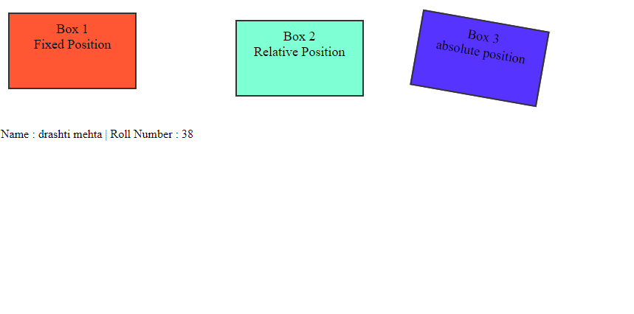

1. Create an HTML form with fields for name, email, phone number and message

* Use CSS to style the input fields, including textboxes, bordered inputs coloured inputs and focused inputs
* Add icons to the input fields using CSS
* Style the text areas and select menus in the form
* Use CSS to style the input buttons in the form
* Create responsive form using CSS media queries

Code:

<!DOCTYPE html>

<html>

<head>

<title>responsive form using CSS media queries</title>

<meta name="viewport" content="width=device-width, initial-scale=1.0" />

<link rel="stylesheet" href="https://cdnjs.cloudflare.com/ajax/libs/font-awesome/4.7.0/css/font-awesome.min.css">

<style>

* {

margin: 0;

padding: 0;

box-sizing: border-box;

font-family: sans-serif;

}

body {

display: flex;

align-items: center;

justify-content: center;

background: #037ef3;

padding: 10px 0;

}

.form-container {

width: 100%;

background: #fff;

padding: 10px;

max-width: 450px;

border-radius: 15px;

box-shadow: rgba(97, 95, 95, 0.1) 10px 0px 50px;

}

.form-container__details {

margin-bottom: 40px;

text-align: center;

}

.form-container__title {

font-size: 38px;

color: #555;

margin-bottom: 7px;

}

.form__label {

margin-bottom: 5px;

font-size: 15px;

font-weight: 600;

color: #777;

}

.input-icons i {

position: absolute;

}

.input-icons {

width: 100%;

margin-bottom: 10px;

}

.icon {

padding: 10px;

min-width: 40px;

}

.input-field {

width: 100%;

padding: 10px;

border-radius: 5px solid rgb(202, 198, 198);

text-align: center;

}

.text_message {

width: 100%;

height: 150px;

padding: 5px;

}

.form__submit {

background: #037ef3;

color: #fff;

font-weight: 600;

width: 100%;

border-radius: 5px;

cursor: pointer;

padding: 10px 15px;

margin-bottom: 10px;

border: 0;

transition: all 0.8s;

font-size: 18px;

}

.form__submit:hover {

background: #0271da;

}

.custom-select {

width: 100%;

padding: 10px;

}

@media (max-width: 600px) {

.form-container {

padding: 30px 25px;

width: 90%;

}

.icon {

padding: 18px 15px;

min-width: 40px;

}

.input-field,

.form__submit {

padding: 18px 15px;

}

}

</style>

</head>

<body>

<div class="form-container">

<div class="form-container__details">

<div class="form-container__title">Registration Form</div>

</div>

<form class="form">

<div class="input-icons">

<div class="form__label">Name</div>

<i class="fa fa-user icon"></i>

<input class="input-field" type="text" placeholder="Enter Your Name">

</div>

<div class="input-icons">

<div class="form__label">Email</div>

<i class="fa fa-envelope icon"></i>

<input class="input-field" type="text" placeholder="Enter Your Email">

</div>

<div class="input-icons">

<div class="form__label">Phone Number</div>

<i class="fa fa-phone icon"></i>

<input class="input-field" type="text" placeholder="Enter Your Email">

</div>

<div>

<div class="input-icons">

<div class="form__label">Message</div>

<textarea name="subject" placeholder="Write something.." class="text_message"></textarea>

</div>

<div class="input-icons">

<select class="custom-select">

<option value="0">Select Course </option>

<option value="1">BCA</option>

<option value="2">B.Com</option>

<option value="3">BBA</option>

<option value="4">MCA</option>

<option value="5">MBA</option>

</select>

</div>

</div>

<input type="button" value="submit" class="form__submit">

</form>

<center>

<p>Name : drashti mehta | Roll Number : 38 </p>

</center>

</div>

</body>

</html>

Output:

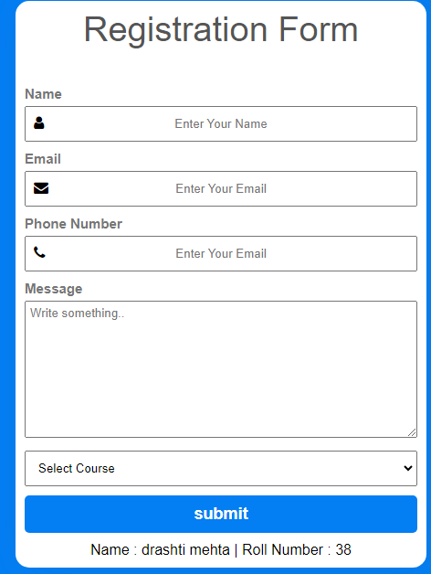

1. Create an HTML document with a header navigation menu, content area, and footer

* Use CSS to create a responsive design using media queries
* Adjust the layout and styling of the header, navigation menu, content area and footer based on screen size
* Use CSS to create a responsive menu that collapses on the smaller screens
* Apply different background color to the header and footer on different screen sizes

Code:

<!DOCTYPE html>

<html>

<head>

<meta charset="UTF-8">

<meta name="viewport" content="width=device-width, initial-scale=1">

<title>Responsive Web Page</title>

<style>

/* Base styles for the header, navigation, content, and footer */

body {

margin: 0;

padding: 0;

font-family: Arial, sans-serif;

}

header {

background-color: #889cdd;

color: #fff;

text-align: center;

padding: 20px;

}

nav {

background-color: #444;

display: flex;

padding: 10px;

}

nav ul {

list-style-type: none;

padding: 0;

display: flex;

}

nav ul li {

display: inline;

margin-right: 20px;

}

nav ul li a {

text-decoration: none;

color: #cacaca;

}

nav ul li a:hover {

color: white;

font-weight: bold;

}

section {

margin-bottom: 20px;

border-radius: .5rem;

padding: 20px;

margin: 20px;

border: 1px solid #ccc;

background-color: #f9f9f9;

}

.content {

padding: 20px;

}

footer {

background-color: #889cdd;

color: #fff;

text-align: center;

padding: 30px;

}

/* Media queries for responsiveness */

@media (max-width: 768px) {

nav ul {

flex-direction: column;

text-align: center;

}

nav li {

margin: 10px 0;

}

}

@media (max-width: 480px) {

header {

background-color: #797979;

}

footer {

background-color: #797979;

}

}

</style>

</head>

<body>

<header>

<h1>responsive design using media queries</h1>

</header>

<nav>

<ul>

<li><a href="#">Home</a></li>

<li><a href="#">About</a></li>

<li><a href="#">Services</a></li>

<li><a href="#">Contact</a></li>

</ul>

</nav>

<div class="content">

<h2>Welcome to our website!</h2>

<p>This is the content area. It will adapt based on screen size.</p>

<section>

<h2>Contact Information</h2>

<address>

<p>Name: drashti mehta</p>

<P>Address : rajkot,gujarat,india 360007</P>

<p>Email: <a href="mailto:drashtii2012@gmail.com">drashtii2012@gmail.com</a></p>

<p>Phone: 6359692202</p>

</address>

</section>

</div>

<footer>

Developed by © 2023 drashti mehta Responsive Website

</footer>

<center>

<p>Name : drashti mehta | Roll Number : 38 </p>

</center>

</body>

</html>

Output:

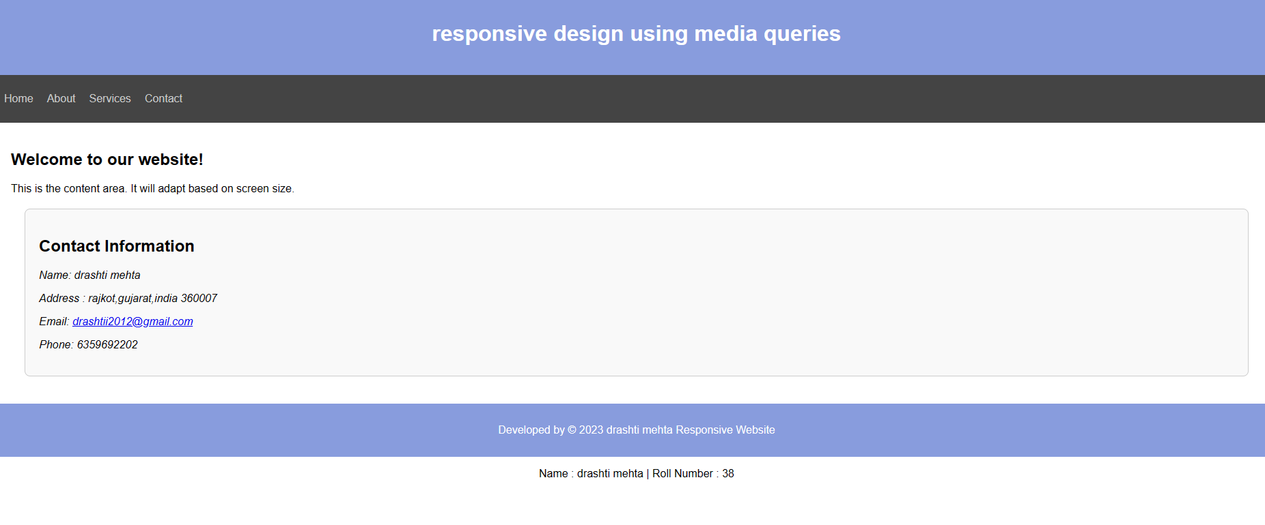

1. Create an HTML document with at least 4 div elements, each containing an image and a heading

* Use CSS to apply a border, padding, & margin to each div element
* Apply different position values to each div element to create a grid layout
* Use CSS to float the images to the left or right of the headings
* Apply transformation and transition effects to the images
* Create a hover effect using CSS for the div elements

Code:

<!DOCTYPE html>

<html>

<head>

<meta charset="UTF-8">

<meta name="viewport" content="width=device-width, initial-scale=1">

<title>Image Grid</title>

<style>

body {

font-family: Arial, sans-serif;

}

div {

width: 70%;

}

h2 {

text-align: center;

}

.grid {

display: grid;

padding-left: 250px;

grid-template-columns: repeat(2, 1fr);

gap: 10px;

}

.grid div {

border: 2px solid rgb(2, 2, 2);

border-radius: 5px;

padding: 10px;

margin: 5px;

transition: transform 0.3s;

}

.grid div:hover {

transform: scale(1.05);

background-color: rgb(207, 216, 251);

}

.grid img {

width: 100%;

float: left;

transition: transform 0.3s;

}

.grid img:hover {

transform: rotate(10deg);

}

</style>

</head>

<body>

<div class="grid">

<div>

<h2>Image 1</h2>

<img src="c:\xampp\htdocs\html\img1.jfif" alt="Image 1">

</div>

<div>

<h2>Image 2</h2>

<img src="c:\xampp\htdocs\html\img2.jfif" alt="Image 2">

</div>

<div>

<h2>Image 3</h2>

<img src="c:\xampp\htdocs\html\img3.jfif" alt="Image 3">

</div>

<div>

<h2>Image 4</h2>

<img src="c:\xampp\htdocs\html\img4.jfif" alt="Image 4">

</div>

</div>

<center>

<p>Name: drashti mehta | Roll Number : 38 </p>

</center>

</body>

</html>

Output:

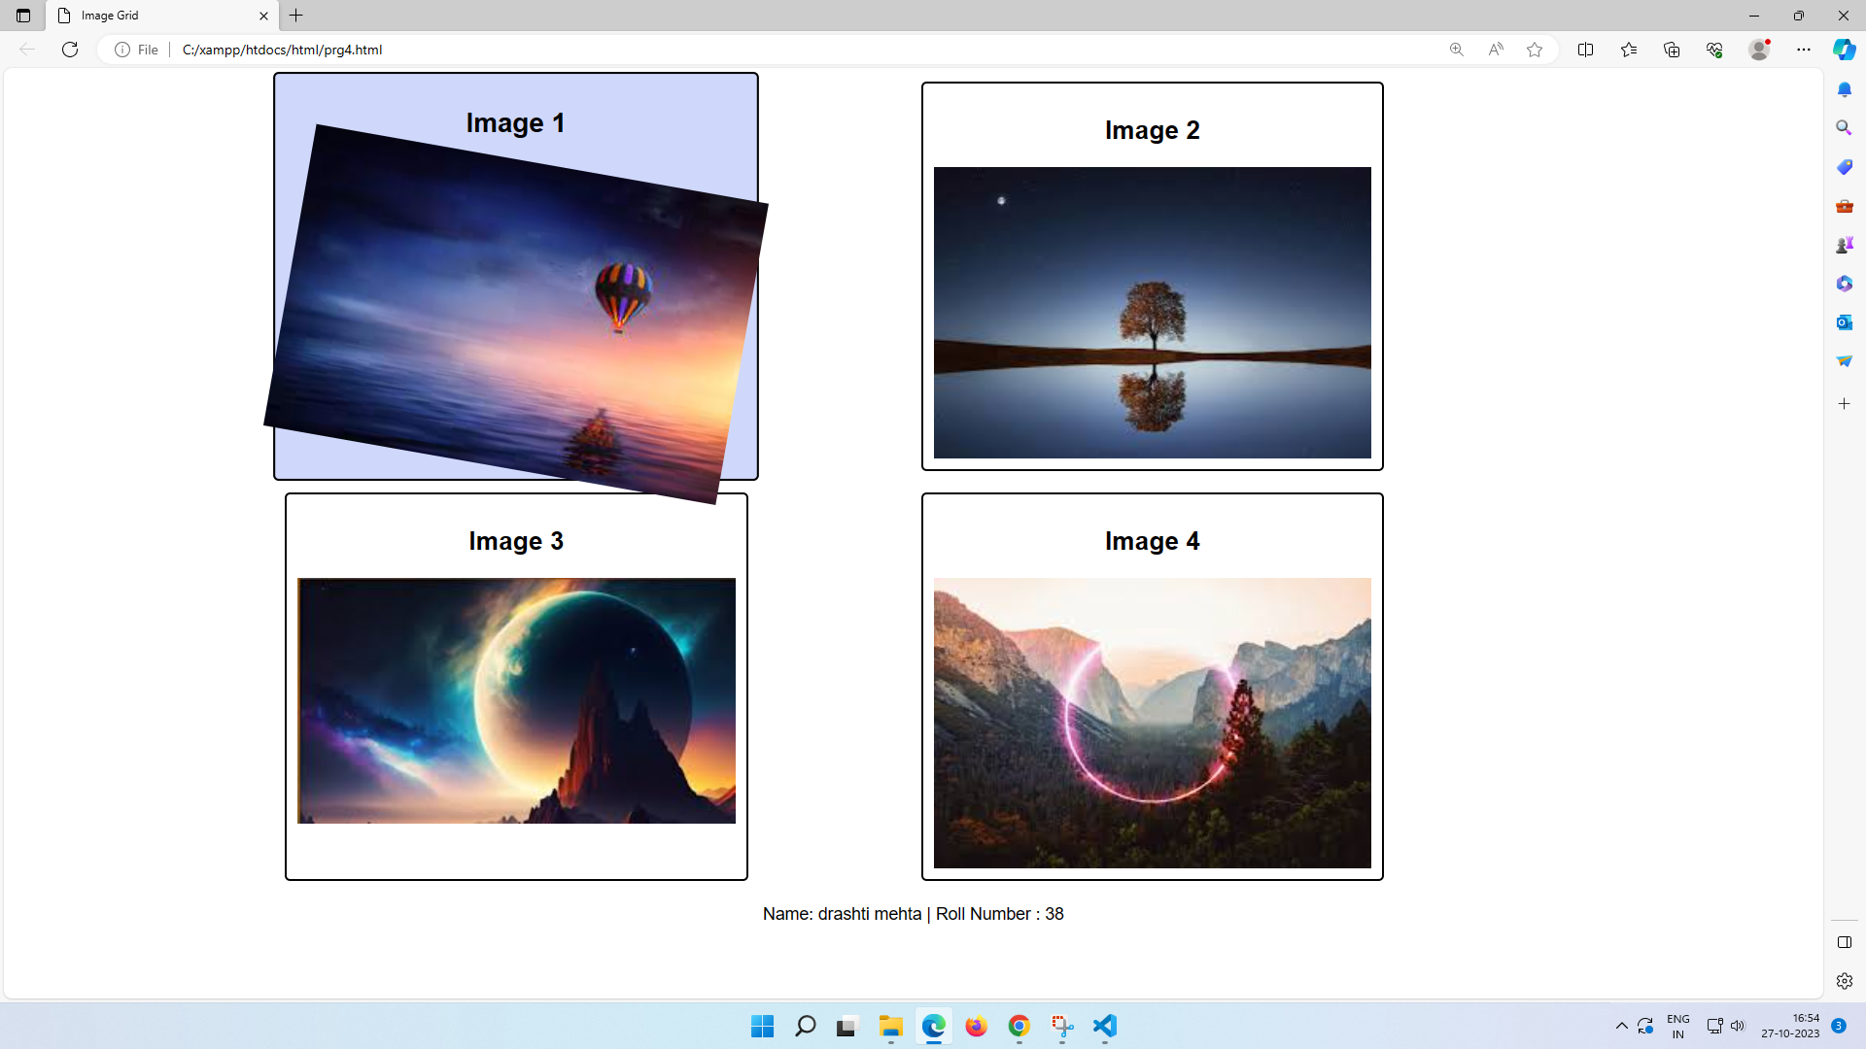

5.Create an HTML form with fields for name, email, phone number, and Address

* Use CSS to style the input fields using CSS
* Style the text areas and select menus in the form
* Use CSS to style the input buttons in the form
* Use HTML5 form validation to validate the email and phone number fields
* Create a responsive form using CSS media queries

Code:

<!DOCTYPE html>

<html>

<head>

<title>Registration</title>

<meta name="viewport" content="width=device-width, initial-scale=1.0" /

<style>

* {

margin: 0;

padding: 0;

box-sizing: border-box;

font-family: sans-serif;

}

body {

display: flex;

align-items: center;

justify-content: center;

background: #d2d3d4;

padding: 10px 0;

}

.form-container {

width: 100%;

background: #fff;

padding: 10px;

max-width: 450px;

border-radius: 15px;

box-shadow: rgba(97, 95, 95, 0.1) 10px 0px 50px;

}

.form-container__details {

margin-bottom: 40px;

text-align: center;

}

.form-container__title {

font-size: 38px;

color: #555;

margin-bottom: 7px;

}

.label {

margin-bottom: 5px;

font-size: 15px;

font-weight: 600;

color: #777;

}

.input {

margin-bottom: 10px;

}

.input-field {

width: 100%;

padding: 10px;

border-radius: 5px solid rgb(202, 198, 198);

margin-bottom: 10px;

}

.input-field:hover {

border: #008CBA solid 2px;

border-radius: 5px;

}

.text_message {

width: 100%;

height: 150px;

padding: 5px;

}

.text_message:hover {

border: #008CBA solid 2px;

border-radius: 5px;

}

.form__submit {

background: #037ef3;

color: #fff;

font-weight: 600;

width: 100%;

border-radius: 5px;

cursor: pointer;

padding: 10px 15px;

margin-bottom: 10px;

border: 0;

transition: all 0.8s;

font-size: 18px;

}

.form__submit:hover {

background: #0271da;

}

.custom-select {

width: 100%;

padding: 10px;

}

@media (max-width: 600px) {

.form-container {

padding: 30px 25px;

width: 90%;

}

.icon {

padding: 18px 15px;

min-width: 40px;

}

.input-field,

.form__submit {

padding: 18px 15px;

}

}

</style>

</head>

<body>

<div class="form-container">

<div class="form-container__details">

<div class="form-container__title">HTML Form</div>

</div>

<form class="form">

<div class="input">

<div class="label">Name</div>

<input class="input-field" type="text" placeholder="Enter Your Name" required>

</div>

<div class="input">

<div class="label">Email</div>

<input class="input-field" type="email" placeholder="demo@gmail.com" required>

</div>

<div class="input">

<div class="label">Phone Number</div>

<input class="input-field" type="tel" placeholder="8234156735" pattern="[0-9]{10}" required>

</div>

<div>

<div class="input">

<div class="label">Address</div>

<textarea name="address" placeholder="Enter Your Address.." class="text_message" required></textarea>

</div>

<div class="input">

<select class="custom-select">

<option value="0">Select Country</option>

<option value="1">canada</option>

<option value="2">america</option>

<option value="3">switzerland</option>

<option value="4">India</option>

<option value="5">australia</option>

</select>

</div>

</div>

<input type="submit" value="submit" class="form__submit">

</form>

<center>

<p>Name : drashti mehta | Roll Number : 38 </p>

</center>

</div>

</body>

</html>

Output:

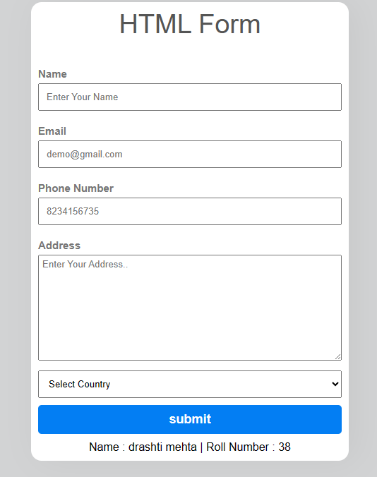

6.Create an HTML document with a header, navigation menu, content area, and footer.

* Use CSS to create a responsive design using media queries
* Adjust the layout and styling of the header, navigation menu, content area and footer based on screen size
* Use CSS to create a responsive navigation menu that collapses on smaller screens and expands on larger screens
* Apply a different background color to the header and footer on different screen sizes
* Use CSS to create a responsive image slider using CSS3 and media queries

Code:

<!DOCTYPE html>

<html lang="en">

<head>

<meta charset="UTF-8">

<meta name="viewport" content="width=device-width, initial-scale=1.0">

<link rel="stylesheet" href="styles.css">

<title>Responsive Design Example</title>

<style>

/* General Styles */

body {

margin: 0;

padding: 0;

font-family: Arial, sans-serif;

}

/* Header Styles */

header {

background-color: #333;

color: #fff;

padding: 20px;

text-align: center;

}

/* Navigation Menu Styles */

nav {

background-color: #f2f2f2;

padding: 10px;

}

nav ul {

margin: 0;

padding: 0;

}

nav li {

display: inline;

margin-right: 10px;

}

nav a {

text-decoration: none;

color: #333;

padding: 5px;

}

/* Content Area Styles */

main {

padding: 20px;

}

section {

margin-bottom: 20px;

}

/* Footer Styles */

footer {

background-color: #333;

color: #fff;

padding: 20px;

text-align: center;

}

/* Responsive Design */

@media only screen and (max-width: 600px) {

/* Adjust header and footer styles */

header {

background-color: #ff0000;

}

footer {

background-color: #00ff00;

}

/* Responsive Navigation Menu */

nav ul {

display: none;

}

nav li {

display: block;

margin-bottom: 10px;

}

nav a {

display: block;

}

}

/* Image Slider Styles */

.slider-container {

width: 100%;

overflow: hidden;

}

.slider {

display: flex;

transition: transform 0.3s ease-in-out;

}

.slider img {

width: 100%;

height: auto;

}

/* Media Queries for Image Slider */

@media only screen and (max-width: 100px) {

.slider {

flex-direction: column;

}

.slider img {

width: 100%;

height: auto;

margin-bottom: 10px;

}

}

body,

html {

margin: 0;

padding: 0;

height: 100%;

}

/* Center the slider */

.slider-container {

display: flex;

justify-content: center;

align-items: center;

height: 100%;

overflow: hidden;

}

/* Hide the overflow of the slider and set its width */

.slider {

display: flex;

overflow: hidden;

width: 100%;

}

/* Style the images within the slider */

.slider img {

width: 50%;

height: auto;

transition: transform 0.5s;

}

/* Add media queries for responsive design */

@media (max-width: 768px) {

.slider img {

max-width: 100%;

}

}

/* Animation for sliding images */

@keyframes slide {

0% {

transform: translateX(0);

}

33% {

transform: translateX(-100%);

}

66% {

transform: translateX(-200%);

}

100% {

transform: translateX(-300%);

}

}

/* Apply animation to the slider images */

.slider img {

animation: slide 12s infinite;

}

</style>

</head>

<body>

<p>DRASHTI MEHTA ROLL_NO 38</p>

<header>

<h1>Animals</h1>

</header>

<nav>

<ul>

<li><a href="#">Home</a></li>

<li><a href="#">About</a></li>

<li><a href="#">Services</a></li>

<li><a href="#">Contact</a></li>

</ul>

</nav>

<main>

<section>

<h2>Content Area</h2>

<p>Below are a few animal-related websites that may interest you. Please note that while we strive to provide only educational, kid-friendly links, we cannot be held responsible for the content of the websites listed on this page..

</p>

</section>

</main>

<section>

<h2>Image Slider</h2>

<div class="slider-container">

<div class="slider">

<img src="IMG1.jpg" alt="Image 2">

<img src="IMG2.jpg" alt="Image 3">

<img src="IMG3.jpg" alt="Image 4">

<img src="IMG4.jpg" alt="Image 5">

</div>

</div>

</section>

<footer>

<p>Footer</p>

</footer>

</body>

</html>

Output:

